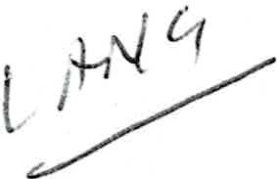
Budapest, 22 November, 2019

Expert Opinion

The expert has been mandated to prepare an Expert Opinion in a letter dated I November 2019. The scope of the Expert Opinion is to assess if Mr. Joshua Frydenberg today is a citizen of Hungary derived from his mother , Mrs. Erica Frydenberg (nee Strausz) who was born in 1943 as a Hungarian citizen. The purpose of the Expert Opinion is to use that in the legal proceeding in front of the High Court of Australia where Mr. Michael Robert Staindl as petitioner filed a lawsuit against Mr. Joshua Frydenberg. For this purpose Mrs. Vanessa Bleyer has mandated the expert to provide the below Expert Opinion in relation to Hungarian citizenship law . The questions raised in Mrs. Vanessa Bleyer's dated 1 November 2019 are answered in the same sequence as contained in the letter.

- In Hungary in 1943 the first citizenship law (Law No. 50 of 1879) was still in force. This law remained in force until I February 1949. A detailed overview is attached under Annexure I containing all four of Hungary' s four citizenship laws from 1880 until today. This overview specifies the ways of acquiring and ceasing to hold Hungarian citizenship respectively . "Ius sanguinu s" has always been a primary principle of Hungarian citizenship law.

In general the first citizenship law was regarded as modern and came into effect on 8 January 1880 (historically when Hungary was still a kingdom), it was fully in line with other European laws from the time. It must be noted that the first amendments to the Law were adopted only 45 years after it stepped into force.

  - This law is codified and is attached under Annexure 2 in Hungarian. No English translation of the law is available , however if necessary, the expert may organize an official translation to English. This would take approximately 7 -8 business days.

- Substantial changes were made to Hungarian citizenship law between 1943 and 1950. On I February 1949 the second citizenship law came into force. A copy of the English version of the law may be found under Annexure 3.

According to Par. 12. of the second citizenship law a female Hungarian citizen shall lose her citizenship in case she marries a foreign individual, except if she does not obtain her husband's citizenship automatically with the marriage. This provision shall apply also to women who have married foreign men prior to the date when this law stepped into force.

It must be noted that prior to the second citizenship law as a consequence of a marriage to a foreign man, the Hungarian female citizen automatically lost her Hungarian citizenship (even if she did not obtain her husband ' s citizenship).

The second citizenship law attempted to mitigate statelessness (loss of Hungarian citizenship) as a result of marriage to a foreign man. This was solved by abolishing the automatic loss of Hungarian citieznship in case of a foreign marriage.

- We are under the assumption that Mrs. Frydenberg was a Hungarian citizen until 1948 or 1949. Mrs. Frydenberg could have theoretically ceased to hold Hungarian citizenship based on the second or third citizenship law , please check II and III, column 4. We understand that based on II (second citizenship law) marriage and legalization are not applicable, dismissal is unlikely due to her age (she was still a minor 1957), only divestment may come into question. If she was divested, a resolution thereof was published in the Hungarian Gazette (column 5).

Based on III (third citizenship law - Annexure 4) Mrs. Frydenberg ' s citizenship could have ceased by dismissal (she became an adult after 1957) or divestment. Again, this resolution should have been published in the Hungarian Gazette and is therefore public record.

- If it is necessary to prove that Mrs. Frydenberg ceased to hold Hungarian citizenship under Hungarian law the only evidence is a resolution of divestment adopted by the Minister of Interior Affairs or the President of Hungary as indicated above under answer 3.

The expert has approached the Hungarian National Library / Archive in an e-mail dated November 6, 2019 (Annexure 7) with the question if a resolution on divestment was published. The National Archive informed that they do not issue information without a power of attorney (in this case from Mrs Frydenberg).

In order to overcome this I can only suggest to check in the Hungarian Gazette ("Magyar Kozlony") all resolutions between 1950 and 1971 to see if there has been a divestment. This Gazette is public record, but is is unavailable digitally. I would have to check them on paper in the Nationa Library, I cannot forecast the number of hours necessary.

5.

  - Hungary ' s first passport law was adopted in 1903. After 1945 laws and regulations on issuing passport and foreign travel were not made public, these were not published in official journals. Rules on travelling abroad became very strict after 1945, this is symbolized by the low number of issued passport and high number of official travels. Passports were issued by the Minister of Inter Affairs and from 1948 by the State Protection Authority (" AVH ' ). The applications and permits from the passport departments of the time cannot be found in the national library or archives , these documents were presumably destroyed.

The expert is not aware of a travel document with single exit and no right to return . The expert is aware however of passports issued for a single trip (there and back). Emigration in the time was substantial, partly by the previous reigning regime, partly by politicians afraid of communism and partly by Jews feeling from holocaust. This emigration was partially carried out by ordinary passports issued in in unlawful manner (Bencsik Peter - " A Magyar ittiokmanyok tdrtenete " - 1945 I 1961, page 19 ).

  - A person who possessed a Titre d'ld entite et de Vo yage document would not lose his / her Hungarian citizenship. The reasons based on which a Hungarian citizenship would have ceased to hold Hungarian citizenship are explicitly listed in the citizenship laws.

6.

- The experts understanding of "stateless" or "stateless person" around 1948 or 1949 is a person who has been dismissed or divested from Hungarian citizenship and holds therefore no Hungarian or any other foreign citizenship. It must be noted that dismissal under I and II were possible without obtaining a foreign citizenship. Only III (third citizenship law) introduced that dismissal was only approved if a foreign citizenship was already in place.

- It would be unprofessional for the expert to judge how and on what grounds the Titre d'ldentite et de Voyage was issued in or around 1948 and I 949.

- The expert can stress that the Titre d'ldentite et de Voyage issued by the Chief of Police in Paris cannot determine ones citizenship status. Certainly it could NOT have had an impact from a Hungarian perspective.

It must be noted that the expert unaware of the facts and statements which were presented in Paris based on which the Chief of Police in Paris issued the Titre d' Iden tite et de Voyage,

furthermore this has no significance from the Hungarian point of view. The only question for determining Mrs. Frydenberg ' s citizenship is whether a resolution on divestment was ever issued and made public.

- In light of the above matters it is to the expert' s best opinion that Erica was a citizen of Hungary in 1950 in case there is no public resolution of divestment.

It must be noted that any Hungarian / non - Hungarian citizen has the right to approach the Minister of Interior Affairs with the request to issue a certificate of citizenship (" allampolgarsagi bizonvitvanv" ) (fourth citizenship law 10 § - Annexure 5).

Following documents must be attached to the request (Annexure 6):

(i.) Birth certificate (ii.) Marriage certificate
(iii.) Birth and marriage certificate of the parents
(iv.) If the applicant has no legal domicile in Hungary a power of attorney for delivery agent

It must be noted that not only the persons who claim to hold / not to hold Hungarian citizenship are entitled to file such application, but also third parties who verify their substantial lawful interest thereto (perhaps even petitioner of the Australian legal proceeding).

- Yes, it is the expert's opinion that Erica was a citizen of Hungary in 1950 in case no resolution issued by the Minister of Interior Affairs or the President was adopted and published. The only factual matters which could have influenced her Hungarian citizenship are the followings.

(i.) Marriage - We understand that Mrs. Frydendberg married in Australia , and did not receive citizenship due to marriage (as a consequence of which she did not lose her Hungarian citizenship under II). Marriage as a way of ceasing to hold Hungarian citizenship is no longer relevant under III.
(ii.) Paternal acknowledgement - not relevant (iii.) Dismissal - can only be relevant under III. (iv.) Divestment - can only be relevant under III.

The period to be investigated for the expert is 1943 to 1971. It is irrelevant if Mrs. Frydenberg lost her Hungarian citizenship in any way after 17 July 1971.

- If Mrs. Frydenberg was not divested from her Hungarian citizenship, her Hungarian citizenship has not ceased, therefore at the time of Mr. Frydenberg ' s birth on 17 July, 1971 she remained a Hungarian citizen.

- Yes, it is the expert ' s opinion that Mr. Frydenberg became a Hungarian citizen with his birth on 17 July 1971 irrespective of his place of birth provided that at the time of birth Mrs. Frydenberg was still a Hungarian citizen. Ius sanguinus is applicable, therefore a Hungarian natural persons (male or female) child is Hungarian by birth .

- If Mr. Frydenberg became a Hungarian citizen at birth, therefore we assume he was also a Hungarian citizen on 18 May 2019 provided he has not filed and successfully completed an application on renouncement to the President of Hungary. The citizenship ceases on the day when the President issues the certificate . We are not aware of such application .

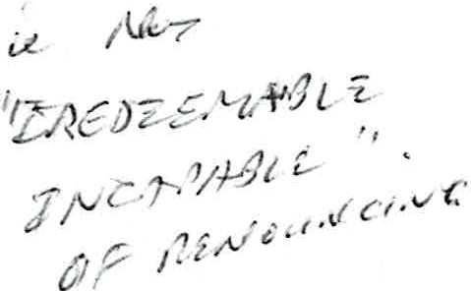
- Indeed there is a possibility for Mr . Frydenberg to renounce his Hungarian citizenship . In fact any Hungarian citizen may file a request to renounce his / her Hungarian citizenship to the President of Hungary who

  - lives abroad,
  - has no permanent address in Hungary,
  - has obtained a foreign citizenship,
  - is not subject to a pending criminal proceeding in Hungary and
  - has no tax other public debts in Hunga ry.

I
'-._.,,

The application may be filed at Hungarian embassies or consulates . The application is filed within 5 days from receipt to the Office of Migration and Citizenship. Based on the motion of the Office of Migration and Citizenship the Minster of Interior Affairs will issue a proposal within 60 days to the President of Hunga ry. Subsequently a decision will be made within another 60 days. The Hungarian citizenship will cease on the day when the President issues the certificate. The form to renounce is attached under Annexure 8.

Please let me know if you have any comments or queries.

Sincerely yours,

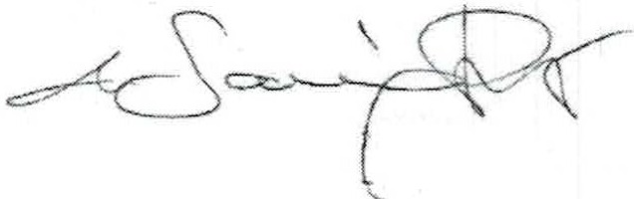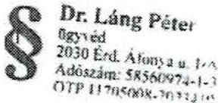

DDr. Peter Lang, PhD Attorney-at-law Expert

Annexures:
- Overview
- Law 50 of 1879 (First citizenship law)
- Law 60 of 1948 (Second citizenship law)
- Law 5 of 19 57 (Third citizenship law)
- Law 55 of 1993 (Fourth citizenship law)
- Form to request certificate of citizenship
- Request on obtaining information on dismissal
- Declaration on renouncement of Hungarian citizenship

